Find - Replace Counts

The Name fields are not case sensitive. The program makes them uppercase before searching for the counts.

There are three options for searching for the counts. Single which allows you to manually choose which callouts to replace. All sPole will search all sPoles for the counts to replace. All Callouts will search all callouts for the counts to replace.

Setup:

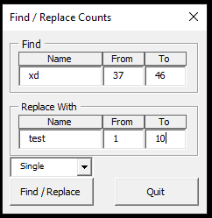

Before:

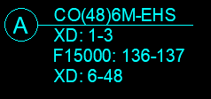

After:

